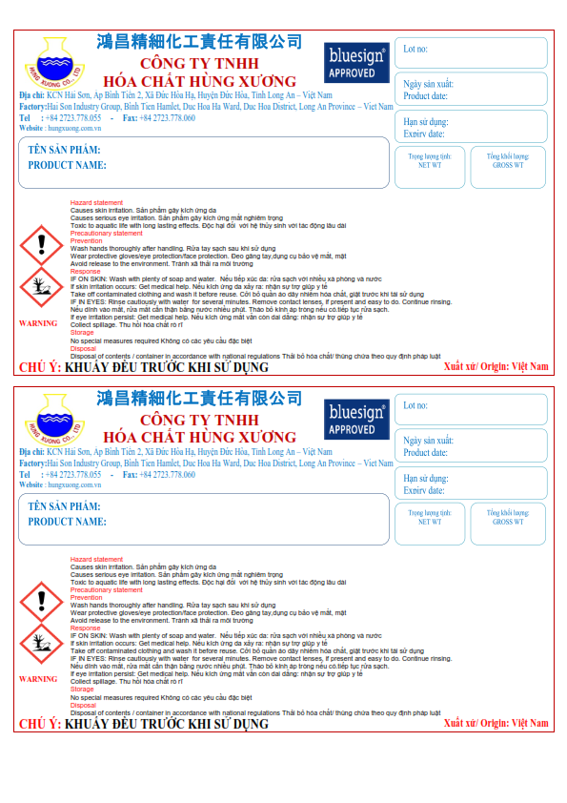

**126KG**

**120KG**

**126KG**

**120KG**

**HUNTEX LD-450**

**01/02/2022**

**01/08/2021**

**HUNTEX LD-450**

**B0061229**

**01/02/2022**

**01/08/2021**

**B0061229**